1. Should we have a Sort function to display room by level? So that it’s easier for the user to see/use
2. Room service order -> view order -> view non-existent order
   1. This bit is buggy cos it prints “order doesnt exit“
   2. Then it breaks and here’s the error code
   3. 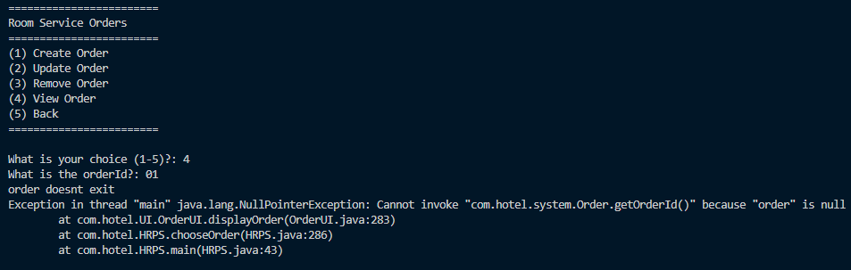

Reservation

1. Create reservation:
   1. have a format definition (DD/MM/YYYY or MM/DD/YYYY) and error catching for date so that the system doesn’t break
   2. It says to enter a date before today’s date, but it should be any date after today’s date
   3. Date for check in goes into inf loop after the first error
   4. When creating a new guest, if I enter a name with a space, it immediately breaks and goes into an inf loop (string input need to allow multiple words per name)
   5. When entering card, tell users that it’s 16 numbers
      1. Can we use the numbers to determine card type? I know this is a lot of work ah but it’d be nice to have
   6.  can change the y/n to caps for all this type so that it’s consistent?
2. Update reservation
   1. For some reason the last available room cannot be selected for customer to change room, but it works after
   2. 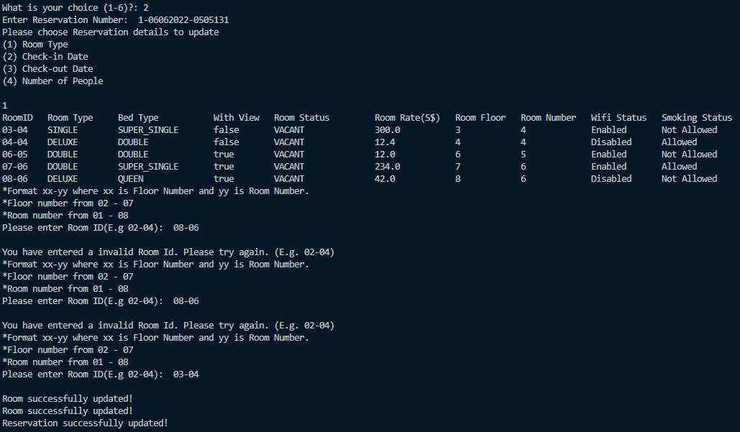
   3. Updating the check in and out date immediately fails
   4. 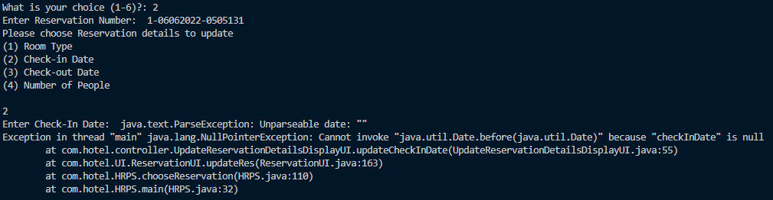
   5. 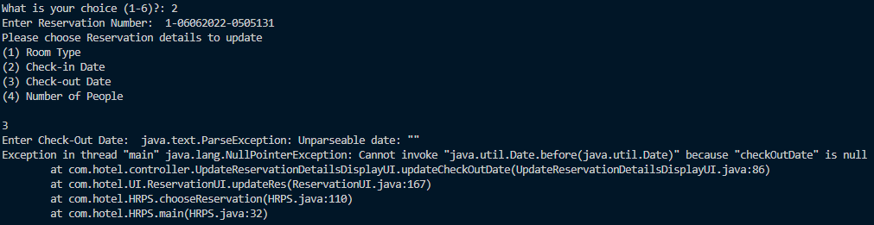
   6. If the number of people == 0, it is still allowed. Should we be allowing this?
3. Remove reservation
   1. When trying to remove reservation, there’s no UI printed
   2. It will keep just doing nothing if we keep pressing enter after the choice 3 to remove reservation is selected
   3. After that, if we enter a reservation number, we need to press enter twice for it to c
   4. and it will never be able to find a reservation